# Ethics committee approval application

## Title of project: experimental philosophy exploratory research

**Participating researchers:**

* Brent Strickland (postdoctoral researcher, CNRS) [Corresponding researcher]
* Students, Post-docs and ITAs supervised by the persons above

**Location:** on-line

**Date:** 06/01/2015

## Introduction: explicit and implicit judgements of events, causality, moral reasoning and naive theories of social cognition

Philosophy has for a long time been a science of intuition for most of it, where intellectuals would draw educated conclusions, often claimed to be universal, about the nature of right and wrong, the meaning of words, causality, and social processes. Experimental Philosophy is an emerging branch of philosophy that aims at validating such intuitions empirically by taking questions from philosophy and testing them with the rigor and methods of experimental psychology.

In 2013, Dr Brent Strickland started the Experimental Philosophy Group in order to take part in the efforts of this field. The group includes individuals from the Jean Nicod Institute — a high figure French laboratory with a focus on analytical philosophy, linguistics and social science, and a research unit of the French National Center for Research, CNRS — and the LSCP — Laboratory of Cognitive Sciences and Psycholinguistics, under the supervision of the Département d'Etudes Cognitives of the Ecole Normale Supérieure.

As a part of this group's work, we are investigating novel explicit and implicit judgements of events (example 1), causality (example 2), moral reasoning (example 3) and naive theories of social cognition (example 4). All of our studies will have common traits:

* They will examine people aged 18 years and older
* They will take place on-line, and thus will require no effort on the part of the participant other than visiting a webpage.
* They will be relatively short (less than an hour of actual experiment time)
* They will be strictly non-invasive and present no risk
* They will be compensated (and subjects know in advance the amount)
* They will be preceded by an informed consent form including information about the absence of risk and the compensation.

All of the studies on this project will be based on on-line experiments consisting strictly of questionnaires (either text, image, sound or video based) accompanied by an input collection method. Collected data may only comprise button clicks, typed answer, keystrokes, response times, and mouse motion.

## Risks and benefits

There will be no risks or benefits associated with this research. All experiments will take place through a website and will present only text, images, sounds and video.

## Compensation

Subjects will be compensated by an amount specified in advanced on Amazon Mechanical Turk. Payment will range between 5 cents per response and $5 (depending on the length of the survey).

## Respect of privacy and confidentiality of data

All participants will be recruited through Amazon Mechanical Turk and data will be collected and stored entirely anonymously. The consent forms and demographic forms will not contain any information allowing for the identification of the participants (see annexes for examples of such forms).

## Examples

**Example 1: Judgement of Events Experiment**, ie. how does the mind split, remember, understands events.

Here's the example of an experiment that we would like to follow up on as part of our investigation of the judgement of events.

Event segmentation is the fact that the mind reflexively carves up our continuous experience into discrete events ; doing so, it saves ressources when processing or memorizing those informations. This cognitive process is highly involved in some perception bias, but yet is still badly known.

Jeffrey Zacks' theory (the only well known author on the topic) is known as “Prediction Error”: it says that the brain is constaltly making predictions about how the environment is supposed to evolve, and any error in those predictions would lead to a segmentation (Zacks & Swallow, 2007).

This study challenges Zacks' theory and proposes a second theory called “Change Theory”: it says that some changes (color, direction...) would lead to more or less important segmentations.

In order to discriminate between Change and Prediction Error theories, a series of experiments was conducted. In one of them, representative of the sort of stimuli used in this study, participants were shown a video of a ball travelling down a pipe with either an expected change in its trajectory or an unexpected non-change. Subjects were then asked to press a key whenever they feel an event has ended and another has started.

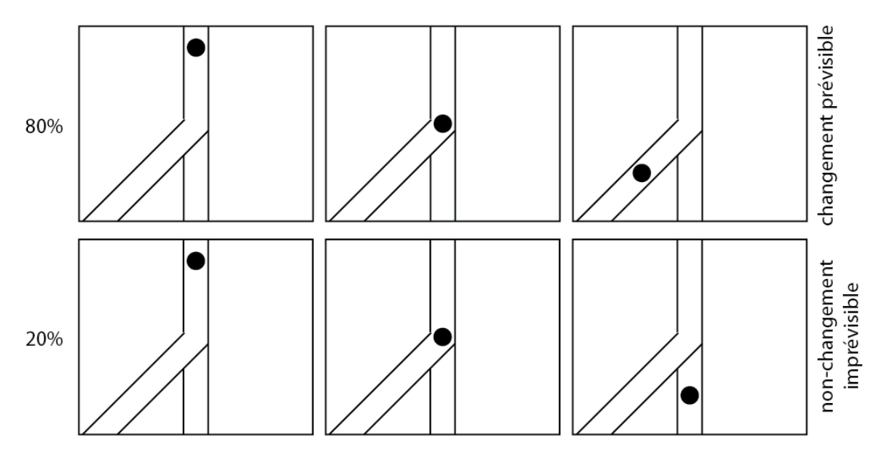

Figure - Representation of the different items used as stimuli

**Example 2: causality experiment**, ie. how does the mind infer causality links between various events.

Here's the example of a study that we would like to follow up on as part of our investigation on causality.

This study demonstrates that the visual system automatically discriminates causal from non-causal events, and only in the former case is it sensitive to Newtonian speed regularities. According to Newtonian mechanics, in a simple billiard ball-like collision in which ball A strikes ball B, B's resulting speed cannot be more than twice than the original speed of A. However, A's initial speed can be virtually any multiple of the resulting speed of B.

One of the experiments of this study, representative of the sort of stimuli used in the other experiments, shows that when participants observe causal events that violate the above principle, e.g. if B moves at 3 times the original speed of A, they robustly report perceiving a causal relationship, but one that is unnatural.



Figure - Screenshot of the video

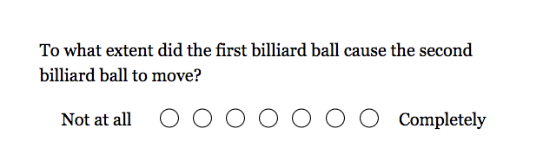

Figure - Screenshot of the question following the video

**Example 3: Moral Reasonning Experiment**

As an example of the sort of experiments we would like to run, here's a description of an experiment used to show the "Knobe effect" as depicted by Knobe (2006).

Subjects are told the following story: The vice-president of a company went to the chairman of the board and said, "We are thinking of starting a new program. It will help us increase profits, but it will also harm the environment." The chairman of the board answered, "I don't care at all about harming the environment. I just want to make as much profit as I can. Let's start the new program." They started the new program. Sure enough, the environment was harmed.

Subjects are then asked "Did the chairman of the board intentionally harm the environment?"

Most participants answer "yes" to this question, justifying this answer by talking about the chairman's psychological state. Though, replacing "harm the environment" with "help the environment" in both the story and the question radically changes participant's answer to "no".

This type of study can be run as a simple on-line text based study.

**Example 4: naive theories of social cognition**

Here's an example of a subject that we would like to investigate.

Philosophers of language have distinguished between "what is said" and "what is implied" by appeal to intuitions about lying. Let's consider an example where a professor asks a student (who knows she will be unavailable) if she will be coming to today's lecture. She replies either "I will be there" or "there is nothing else I'd rather do." Philosphers say that in the first case she literally said she would not be coming while in the second case this is merely implied. To justify this claim, they point out that only in the first case do people have the intuition that the girl lied. However, an experimental philosopher would like to test this claim empirically as opposed to taking the philosophers' word for it.

In a simple on-line study, we might ask whether the girl was lying or misleading. This study would involve a simple text based stimuli.

## Bibliography

* Knobe, J. (2006). The concept of intentional action: A case study in the uses of folk psychology. Philosophical Studies, 130(2), 203-231.
* Zacks, J., & Swallow, K. (2007). Event Segmentation. Current directions in psychological science, 16, 2.

## Annexes

**Consent form example**

*Description of the study:*

The purpose of this research study is to examine how people perceive certain events. In this experiment, you will be shown short videos and will be asked some questions about the events in the videos.

*Age:*

You must be 18 years of age or older to participate in this study.

*Risks, Benefits, and Confidentiality:*

There are no known risks and you will not receive any benefit for participating in the study. All of your responses will be held anonymously. Only the researchers involved in this study and those responsible for research oversight will have access to the information you provide. Your data and information will be completely confidential.

*Compensation:* You will be compensated the amount indicated on mturk.

*Time Commitment:* The study will take about 10 minutes or less.

*Voluntary Participation:* Participation in this study is completely voluntary. You are free to decline to participate.

*Contact Information:* If you have any questions or concerns about any aspect of the study, please contact: Brent Strickland, [brent.strickland@ens.fr](mailto:brent.strickland@ens.fr)

If you agree to the conditions click "I agree" below.

**Demographic form example**

*Type in your age:* ___

*Select your biological sex:* female / male

*What is your education level?*

* before high school degree
* high school degree
* undergraduate degree
* graduate school degree
* higher than graduate school degree